I made my first app using Streamlit in Python.

It’s a visualization app of multiple graphs, on a dataset that explores student performance, as done in last project.

Here’s some examples of how the app may look like:

The home Page

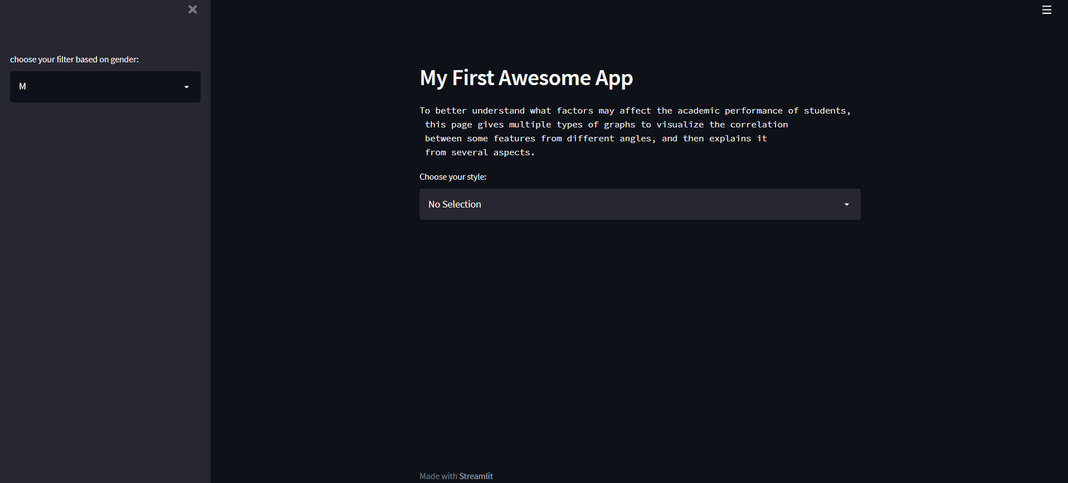

A select box to choose from which type of plot user may prefer to see

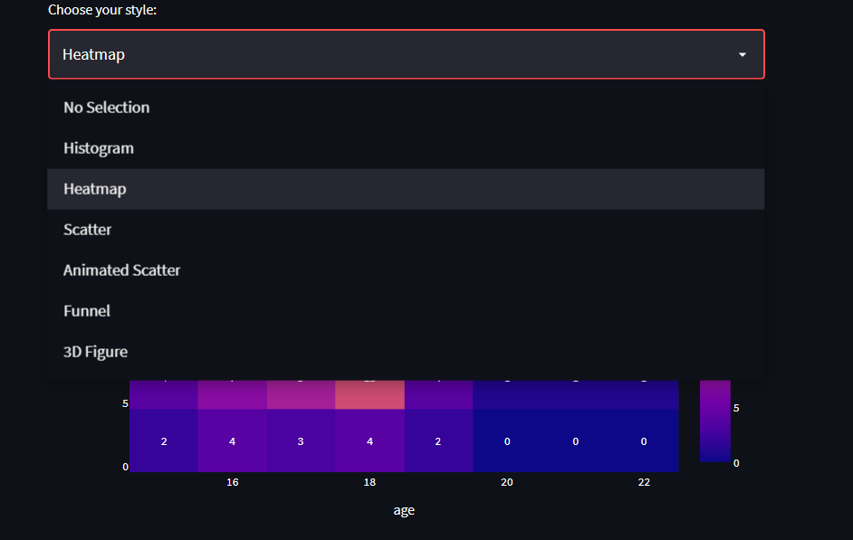

Example of Histogram and a description button of graph insights

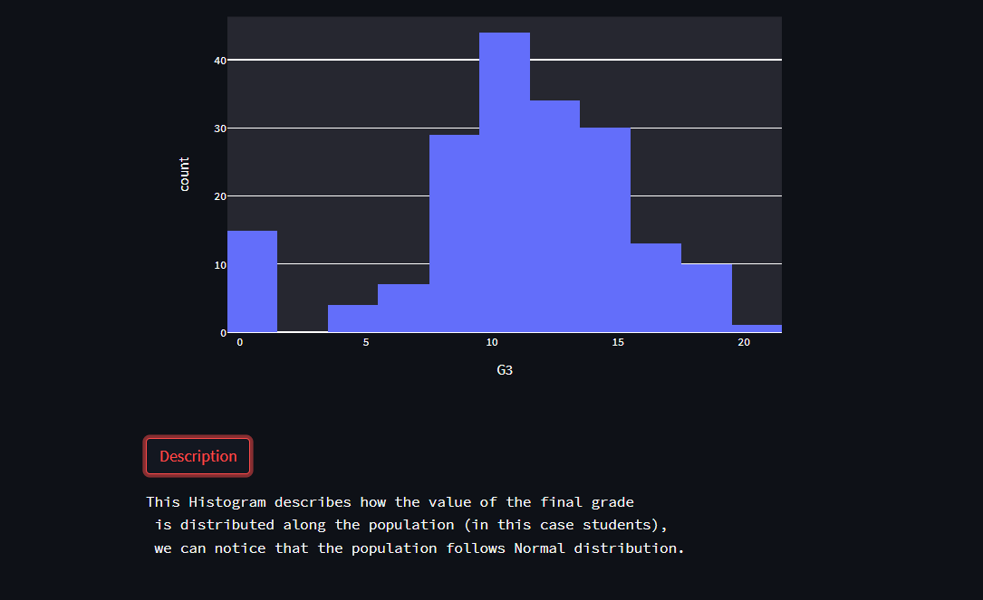

A side bar select box to choose a filter based on gender

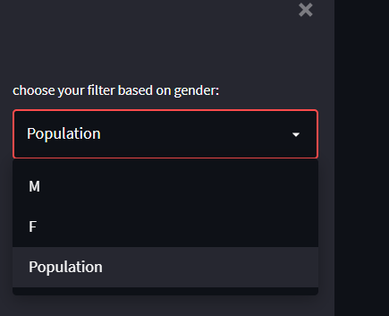

Example of another plot and its description. In this case, it’s an animated scatter with play button.

